**ES 216 Signals, Systems and Networks**

**Assignment 1**

**Name:** Girish Chandar G

**Roll No:** 16110057

**Aim:**

To design Double Side Band Suppressed Carrier modulation and de-modulation systems.

**Theory:**

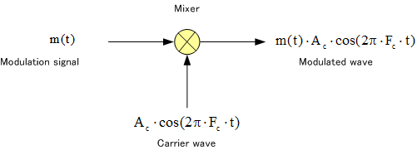

Fig 1:Modulation

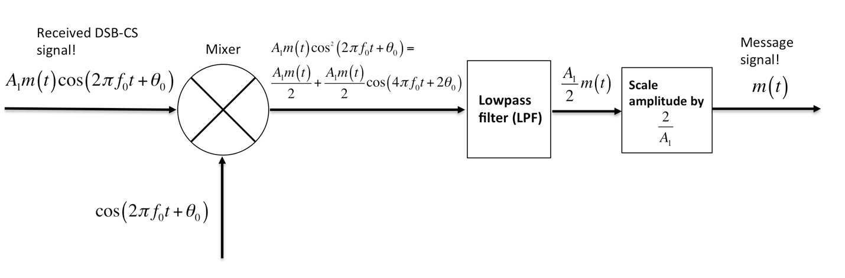

Fig 2:Demodulation

Fig 1 and Fig 2 depict the systemic representation of DSB-SC modulation system and demodulation system respectively.

Modulation is done for the following reasons:

1. Antenna length is proportional to wavelength(wavelength/4) and hence the antenna length will be small for high frequency carrier.
2. High frequency waves have higher energies thus losses due to attenuation is low.

Amplitude modulation occurs when the amplitude of carrier signal is varied according to the message signal (or modulating signal). This is done by multiplying the message signal to the carrier signal.

Demodulation is the process of obtaining the message signal from the modulated signal. To retrieve the message signal, the modulated signal is multiplied with carrier signal and passed through the low pass filter which allows only the lower harmonics of the message signal to pass through. Scaling of amplitude of signal is done to get the original signal back.

**Parameters Used:**

Frequency of message signal: 3Hz

Frequency of carrier signal: 100Hz

Amplitude of message signal: 5

Message Signal: Cosine function

Sampling Frequency: 10000Hz

**Results & Observations:**

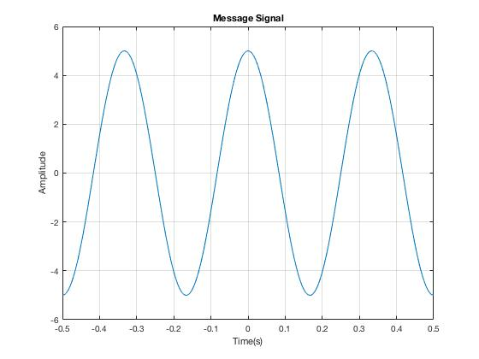

Fig 3: Message Signal

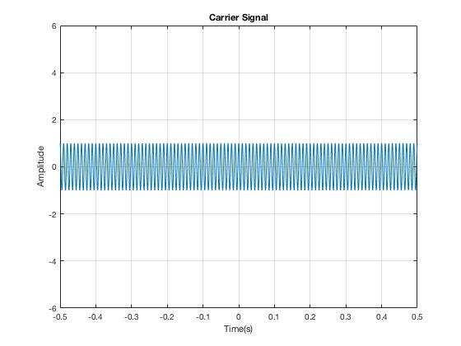

Fig 4: Carrier Signal

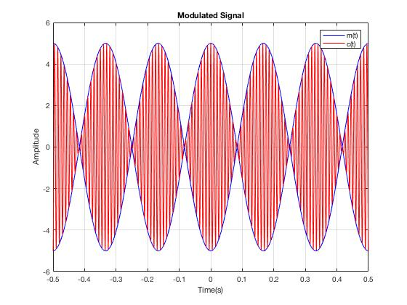

Fig 5:Modulated Signal

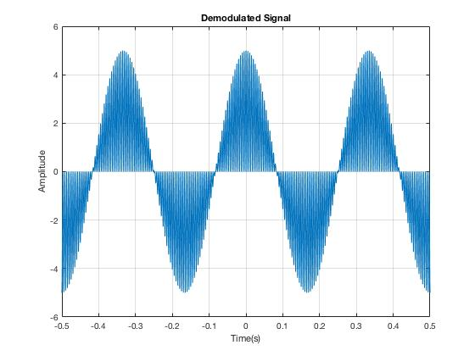

Fig 7: Demodulated Signal

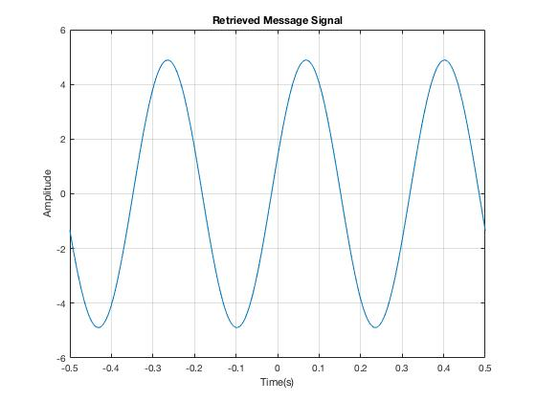

Fig 8: (a)Retrieved message signal (b)Original message signal

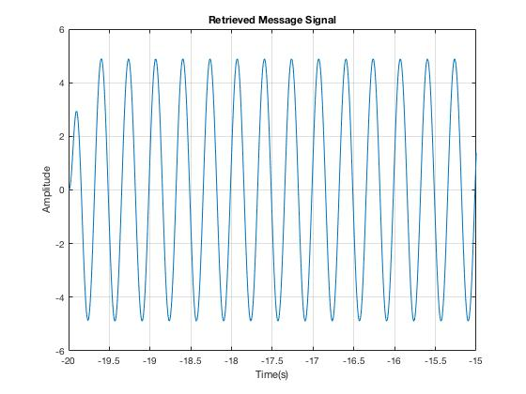

Fig 9: Error in Retrieved Signal

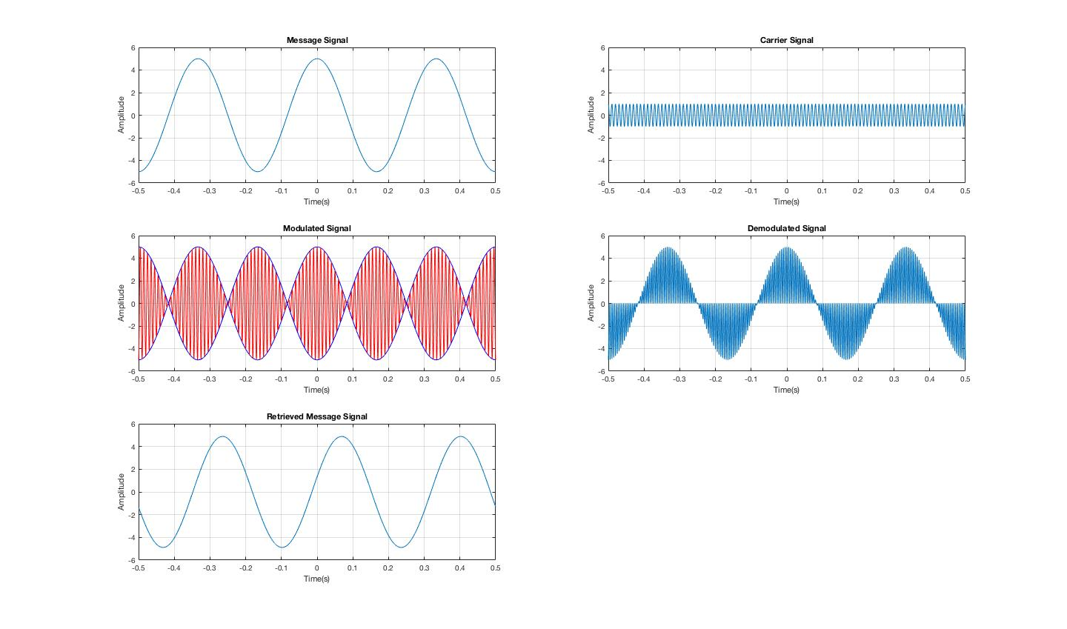

Fig 10: All signals

1. Fig 8 shows the retrieved output signal and the message signal and following observations can be made.
   * Amplitude and Frequency are the same.
   * There is some phase difference between the retrieved and original message signal.
2. There is some error between the message signal and the retrieved signal at the time of generation of the signals as shown in Fig 9.
3. Butterworth filter is used in demodulation system for low pass filter

**References:**

* <https://in.mathworks.com/help/signal/ug/filtering-data-with-signal-processing-toolbox.html>
* <https://in.mathworks.com/help/signal/ref/butter.html?searchHighlight=butterworth&s_tid=doc_srchtitle>
* Fig 1: <http://www.circuitdesign.de/products/tech_info/modulation/images/eq/eq039.gif>
* Fig 2: <http://aaronscher.com/wireless_system_simulations/wireless_system_docs/Slide3.jpg>
* Principles of Linear Systems and Signals by B.P. Lathi